Anne Frank Web Quest

Over one million children under the age of sixteen died in the Holocaust. Anne Frank was one of them.
Introduction: You have just been hired to help create a documentary about Anne Frank and the Children of the Holocaust for the CBS Network. Your job is to visit different web sites to research information about the courage of Anne Frank and other children of the Holocaust. You are to complete each activity or activities assigned by your teacher and follow the instructions that are given. Good Luck!
Tasks
You will choose at least 3 of the activities below to complete. If you have extra time, complete the additional activities as well.
Activity #1
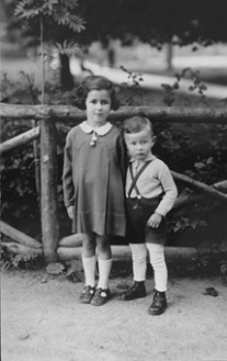
You are going to take a virtual visit to Germany, 1943. You will visit the following web sites to see some faces of the people and scenes related to the Holocaust. Read any data related to the photographs, then answer the following questions about at least 1 photo from each of these 3 links (approximately 1/2 page long text each):
- Write a journal response to the photographs and information given. Describe your emotions and thoughts.

- Which photographs would you choose for the documentary and why? Be sure to give the web site address and name the photograph.

Anne Frank's story in pictures: http://www.annefrank.com/af_life/story_intro.htm
The Children of the Holocaust: http://www.graceproducts.com/fmnc/main.htm
Picture tour: http://remember.org/jacobs/index.html

Activity #2
You are now going to choose some musical selections for our documentary. Explore the following sites to find musical pieces you may want to use. Choose a musical piece that you think could be the theme song or an instrumental for the documentary. Give your reasons for choosing this work.
http://fcit.coedu.usf.edu/holocaust/resource/music.htm This site contains listings of books, articles, annotated musical selections, selected recordings and musical compositions.
http://www.downtownmusicproductions.org/pages/coth01.html This site contains details of Terezin, a Nazi concentration camp. Prisoners were allowed to compose and perform music.
Activity #3
Read the literature about the children of the Holocaust. Select works that especially express the courage and heroic spirit of the children. After selecting 3 works, print each and explain why you chose these particular works
Anne Frank's Diary…selected entries: http://www.annefrank.com/2_life_excerpts.htm
Poem "Daniel" : http://www.mtsu.edu/~baustin/daniel.html
Stories of survivors: http://spidey.sfusd.k12.ca.us/schwww/sch773/review/ngo.html http://spidey.sfusd.k12.ca.us/schwww/sch773/review/manzano.html
Toys: http://www.virtuallynw.com/stories/1997/Oct/25/S297510.asp
Child survivor's testimony on video with audio: http://www.library.yale.edu/testimonies/excerpts/peters.html
Activity # 4
Anne Frank's diary has been translated into many languages. Millions of students read Anne's diary each year. One of the people who assisted Anne and the others in hiding was Miep Gies. Pretend that Miep Gies will be a guest speaker on the show. Read the information concerning Anne's life and her diary. Also read Miep's comments about Anne. Prepare questions to ask Miep Gies about the heroic Anne. Is the diary authentic? How would you prove it to someone who questioned it?
Information about Anne's diary: publication, authenticity, etc. http://www.annefrank.com/download/materialf_storyofdiary.doc - Click "Open"
Anne Frank's House with related information http://www.annefrank.nl/eng/afh/afh.html
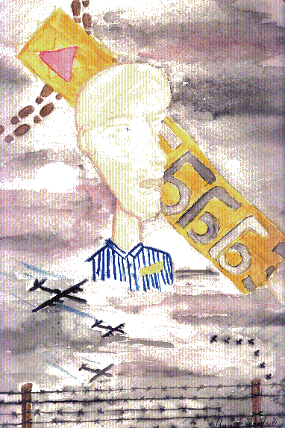
Activity #5
In this activity you will view children's art about the Holocaust. Pretend that you will invite the child artists to the show. Choose three art works from the selections. Write a journal response for each work. Explain why each work best depicts the courage of the children of the Holocaust.
http://remember.org/imagine/imagine1.html

Activity #6
Visit at least three of the following sites which feature stories of survivors of the Holocaust. Choose two of these stories and compare them to Anne Frank. How are they different? How are they the same?
Beyond Secret Tears: http://www.adl.org/children_holocaust/story_beyond_tears.asp Krystyna's Story: http://www.adl.org/children_holocaust/story_krystyna.asp My First Kaddish: http://www.adl.org/children_holocaust/story_first_kaddish.asp Erika Van Hesteren's Story: http://www.humboldt.edu/~rescuers/book/Strobos/ErikaVanHesteren/ErikaStory1.html Eva: Escaping the Death Train: http://www.holocaustsurvivors.org/cgibin/data.show.pl?di=home&da=survivors&ke=6 Jeannine Burk: Hidden Child: http://www.holocaustsurvivors.org/cgibin/data.show.pl?di=home&da=survivors&ke=5

